NEW PRODUCT DEVELOPMENT WITH A/B TESTING

  - Innovations in the Marketplace

  - New Product Development Stages

    - Idea Generation

    - Idea Screening

    - Concept Development and Testing

    - Business Analysis

    - Product Development and Design

    - Test Marketing

    - Commercialization

    - Evaluation and Control

  - The Importance of Testing and Market Research

    - For Design Evaluation

    - For Engaging Customers in an Omnichannel World

    - For Incorporating Feedback and Customer Experience

  - The Intricacies of A/B Testing

  - Using A/B Testing to Test Gaming Prototypes

    - Experimental Design

    - Analyzing the Data and Presenting the Results

    - F Test

    - Testing Statistical Difference

  - Using the A/B Test in New Product Development

    - Insights Derived From the A/B Test

  - Implementation Using R: The A/B Test

  - Understanding the Chapter

LEARNING OBJECTIVES
- Introduce new products in the marketplace
- Recall the steps in the new product development process
- Support new product development with machine learning
- Use A/B testing for new product development
- Introduce a digital product

INNOVATIONS IN THE MARKETPLACE
Chase introduced its new credit card, the Chase Sapphire Reserve, in 2016, which offered users 100,000 sign-up bonus points for the first year and led to Chase exceeding its annual sales target in the first few weeks. The enthusiasm with which millennials adopted the card because of the free points was a key factor in its success. However, Chase needed to see beyond the first year of product introduction to assess how the card would do in the next years after the promotional offer expired and annual fees kicked in. Despite high annual fees of $550, it is considered the best travel card around because of the perks it offers—including airport lounge access and application fee credit for Global Entry and TSA PreCheck.¹ This is one example of a product launch that was designed and launched well, and the right strategies are helping Chase sustain its success.
Nintendo released the Switch in 2017, which sold 2.74 million units in the first month. Its design allowed for handheld and console gaming that appealed to a broad user base. The launch titles, such as The Legend of Zelda: Breath of the Wild, captured people’s attention. The Switch was priced competitively, and its features such as local multiplayer gaming and portability helped it perform successfully in the marketplace.

The concept of a product has evolved in the digital age. Technological advances in artificial intelligence, cloud computing, 3D printing, and wireless sensor networks have now made it possible to build products that do not have a physical presence but that live entirely on the web, such as health monitoring apps on smartphones and facial recognition apps for fraud detection; even in automobiles much of the driving is controlled by algorithms, such as with self-driving technology. Netflix is a good example of how algorithmic power has been harnessed for new product offerings. Netflix began algorithmic recommendation as early as 2010. Gradually algorithms helped it decide which movies to show, how to display them on screens, and which pictures should be used to advertise them. Today the company’s algorithms are not just used for providing recommendations to users; user interactions with the Netflix platform inform the company, for example, what content to develop next and what type of show is likely to garner the most viewership. As early as 2013, Netflix was using predictive analytics to determine what type of new content needed to be included in its show House of Cards to ensure a specific size of viewership.

NEW PRODUCT DEVELOPMENT STAGES
How can we define a new product? Is it something entirely new that customers have never seen before, such as the microwave oven that was introduced as a substitute for the conventional gas/electric range? Or is it a product that is merely an extension of an existing product, or a newer model with enhanced

features, such as a new version of the iPhone that has more memory or functionality than an earlier version? New products get categorized broadly as breakthrough or incremental depending on whether they completely disrupt the existing marketplace or offer newer benefits to consumers. Breakthrough innovations are relatively rare, accounting for less than 10% of all products that get introduced in the marketplace. Many product launches are merely extensions of existing products or me-too products with barely any innovation that are introduced at a lower cost. Moreover, the failure rate for new products is quite high. Many ideas never culminate in a viable product. Even among those new products that do get developed, more than 50% are not profitable. Before we see a product in the marketplace—be it a biotechnology, pharmaceutical, automotive, or digital product—it has gone through a long process of being designed and introduced. What are the steps in new product development? They commonly are the following, with many of these steps being iterative. Next, we will go through the steps in the new product development (NPD) process (see Figure 14.1) in the context of creating an entertaining game with various levels of difficulty.

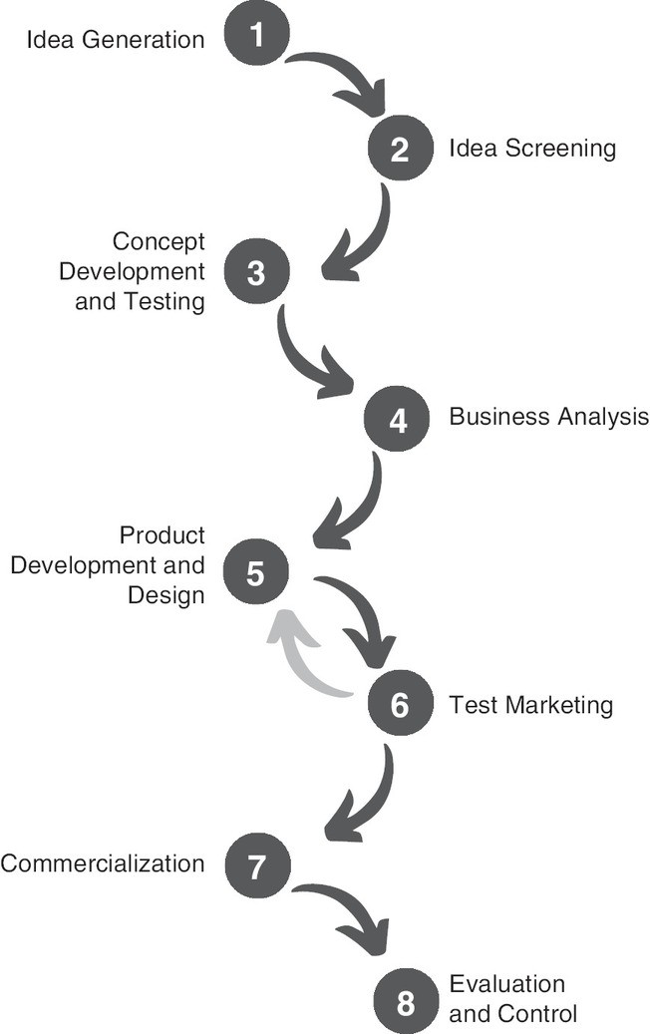

Figure 14.1 New Product Development Process
Description

Idea Generation
The first step of any project is idea generation (this is Step 1 in Figure 14.1). This can be a structured process in some businesses where regular brainstorming involves discussing what consumers need and what type of (as well as whether) new products can be developed. For instance, in some industries, new models or brand extensions are an outcome of such a structured process. Alternatively, new product ideas can emerge as a by-product or even accidentally while working on other projects. In the context of game development, this step could involve generating ideas for a puzzle-adventure game in which players travel different worlds where each world represents a unique level of difficulty. Such a game can be developed in the realm of fantasy, science fiction, or history.

Idea Screening
The second step involves the rigorous evaluation of product ideas with each idea undergoing a comprehensive assessment to determine its viability, innovation, and market appeal.

Viability: This considers whether the idea is technically feasible and economically sustainable, ensuring that the product can be developed as well as marketed successfully.

Innovation: An important criterion is to determine the product idea’s uniqueness or substantial improvement over existing products. It ensures that the product features are indeed novel to the market.

Market Appeal: The idea is evaluated for its potential attractiveness to the intended target segment, determining whether it meets customer needs and preferences effectively.

The aim of this step is to filter and retain only those ideas that show potential for success.

For game development, after careful consideration, the idea of a multilevel, puzzle-adventure game rooted in medieval history was chosen for its engaging concept and scalability.

Concept Development and Testing
In this step, the ideas start to take shape. We can think of it like a sketch turning into a detailed blueprint. The designers start defining the product’s features, how the product functions, and what makes it unique. It is possible that more than one version of the product is built to find the best- performing one. This could involve the shape, size, or weight of a physical product or the seamless connectivity of a digital product. At this step the designers may use surveys or focus groups to test the product with potential users. Consumers’ feedback is helpful in tweaking the product, making sure it is something people will find valuable.

For the puzzle-adventure game, detailed features such as the game rules, objectives, and varying levels of difficulty are established at this step, ensuring that the game is well structured, engaging, immersive, and challenging. To ensure that the developed concept aligns with user expectations and preferences, testing can also be conducted with users in this step.

Business Analysis
The aim of this step is to figure out the business or market viability of the developed concepts. Different types of comprehensive business analysis such as cost estimation, sales projections, and profitability

analysis are conducted to assess the potential business impact and commercial success of the new product.

For game development, this step will involve analyzing the costs associated with developing the game, the product price, and estimating potential revenues based on market research.

Product Development and Design
In this step, the developed concepts are further developed into tangible products. The product design is finalized, incorporating all the necessary features and functionalities, ensuring it’s user-friendly and aesthetically appealing. Prototypes or samples are developed, getting the product ready for market introduction.

This step for our game development example would involve probably programming the game mechanics, designing unique worlds for each difficulty level, and ensuring that the user interface is intuitive and engaging.

Test Marketing
Before the product is launched in the market, it is tested in select markets to obtain user reactions to both design and cost. We can think of this to be a dress rehearsal before the main performance, in which a select audience is invited to provide their review of the performance. This allows for any last- minute adjustments or improvements. The arrow pointing back from Step 6 to Step 5 in Figure 14.1 indicates the possibility of such feedback. Any necessary corrections can be made at this stage based on test market results.

Step 6 for game launch could include the game being soft-launched in select markets or platforms to gather user feedback, analyze gameplay data, and make any needed improvements.

Commercialization
After adjustments or improvements are included in the product following the test marketing step, the product is officially launched in the market. In this step, several marketing strategies are deployed, aiming for a successful launch and a wide market adoption.

When the game is launched in the market, it is likely to involve launching the fully optimized puzzle- adventure game globally, implementing a comprehensive marketing strategy to maximize visibility and downloads.

Evaluation and Control
The new product development process does not conclude after the product launch. The business will closely monitor the product’s market performance. This step involves evaluating the product’s success against the company’s expectations regarding sales as well as customer reviews. It could also include assessment of how well the product performs in comparison to any other competitor that was introduced in the market.

For the game, its performance is continuously monitored postlaunch, and updates are made to improve the game, fix bugs, and keep the content fresh and engaging based on user feedback and evolving gaming trends.

THE IMPORTANCE OF TESTING AND MARKET RESEARCH

As we just learned through the different processes of ideating, designing, and launching a new product, the role of continuously getting feedback from potential users is very important since the process can include many uncertainties. This includes how consumers and competitors will react; if any external factors in the economic or social environment will change before, during, or immediately after the launch; what the price of the product should be; through which channel the product should be launched; and how the product should be promoted. Even before launching a new product in the market, the manager needs to weigh the cost of designing the new product: Will the design be financially viable?
How long will it take to move from design, to production, to launch stage? What does the company have to give up to invest in this new product? In order to answer these questions and reduce some of the uncertainty, companies sometimes conduct surveys to find out which features of the product or launch environment result in greater acceptance by consumers.

For Design Evaluation
Whether the product is digital or physical, it is important to incorporate user experience and feedback into the product during the design stage. A commonly used method to gather user feedback is through A/B testing to find out which product design will attract the most interest. For instance, for digital products like apps that people view online, click rate is used to determine interest (and eventual purchase). As we discussed in Chapter 7, a multi-armed-bandit-based algorithm is now being deployed by large firms to determine quickly which combination of product features will result in the highest interest and purchase.

For Engaging Customers in an Omnichannel World
When the product is ready for launch, algorithms again are used to determine the best way to engage customers in today’s omnichannel world. This has both benefits and shortcomings. Traditionally, people gained product information through one channel such as television or in- store behavior. Today, however, people can be reached through multiple interconnected channels, which makes the task challenging because businesses need to find the optimal channels as well as to customize the message depending on the channel. Hence, a one-message/one-channel policy may not be successful.

For Incorporating Feedback and Customer Experience
Just as user feedback is gathered during the design stage, once the new product is launched it again becomes essential to find out how customers are reacting to it. In the design stage, the feedback is probably gathered from a smaller sample of people, while in the postlaunch stage, a larger set of customers can be reached to find out what they like (or don’t like) about the product. This feedback now happens on an ongoing basis, building a continuous chain from users to designers and back.

THE INTRICACIES OF A/B TESTING
As we discussed in Chapter 7 on advertising, there are several steps that need to be followed to develop a sound A/B test. This includes ensuring that the experimental design is causal (an A/B test is really another name for causal experimentation) and not correlational. For this, we need to ensure that we are keeping all features of the A/B test constant and only varying the feature(s) whose influence we want to examine. Second, we need to create groups (also called conditions or treatments) that vary different levels of the feature that we want to examine. Finally, we should be careful that participants are randomly assigned to the various groups and that there is no issue of self-selection. What exactly is self- selection? Self-selection occurs if participants are allowed to choose which group (or treatment) they want to be part of. For instance, if we design an A/B test for video games to find out which color of the visual interface is more immersive (e.g., blue vs. green) and let participants choose to play using their

choice of color, then the experimental design is not randomized because we are allowing participants to
self-select their experimental group based on color preference.

USING A/B TESTING TO TEST GAMING PROTOTYPES
For this chapter let’s use the example of a video game company. GameV has been working on a new game idea that its designers believe will be more immersive and engaging than other games that GameV currently has developed. However, before they launch the game, GameV designers have generated several prototypes of the game so they can launch the version that is likely to retain the most players. They know from previous data in the gaming industry that every point of engagement in the game results in players who will return. For instance, many players don’t return after the first session because of glitchy install or because of game features that are less than immersive. Therefore, GameV wants to use A/B testing to assess specific features. The game lets players earn an extra life by performing some tasks. GameV has determined three levels of difficulty: 25, 35, and 45. They want to find out which level of difficulty results in greater engagement. It is possible that if players have earned a life by performing a difficult task, it could result in their feeling more engaged. Alternatively, it is possible that earning a life with a more difficult task results in players giving up. Hence, GameV wants to find out which difficulty level engages more players in this game environment. One can think of the three levels of difficulty as low, medium, and high.

GameV believes that a good outcome metric to figure out the success of the prototype is the time players spend playing. Since the game is a prototype, players have never played it before, and the time they spend playing the game will help GameV determine which of the prototypes results in greatest engagement and immersion. The outcome variable (unlike in Chapter 7) is continuous in nature.
Therefore, we will use an F test to find out which level of difficulty results in highest immersiveness.

Experimental Design
GameV has developed the three prototypes in such a way that each prototype is designed with one of the three levels of difficulty. Each prototype offers unique game features that correspond to its specific difficulty level, providing players with a variety of experiences. In the experimental design, the level of difficulty is the only factor that varies across the three prototypes, with specific levels set at 25, 35, and
45. Every other feature of the game stays the same; only the features associated with the level of difficulty are different. Moreover, during A/B testing, a player who plays prototype-25 will not be playing prototype-35 or prototype-45. That is, one player will see and play only one game prototype. Such a design is called a one-factor, between-participants design. GameV followed the usual steps to run its A/B test:

- It recruited 1,200 video game players who agreed to test the game in return for free games from GameV. Hence, the sample for the A/B test is 1,200.
- It randomly assigned about 400 players to each of the three groups: prototype-25, prototype-35, and prototype-45.
- Players played the game for 10 rounds, during which they were presented with the difficulty level specific to their group. They could continue to play after 10 rounds for another 2 rounds, or they could quit and leave.
- Time played was recorded for each participant and served as a measure (also called a proxy) for immersiveness and engagement with the game.
- The null hypothesis would be that changing the difficulty level would not influence the immersiveness, resulting in no difference in the time spent playing among players in the three groups.

Analyzing the Data and Presenting the Results

Before we determine what analysis needs to be run, we first should examine the nature of the data. If the data are normally distributed, then we can go ahead and use parametric tests such as an F test or t test. However, if the data are not normally distributed, this failure of the normality assumption might require the use of nonparametric tests like the Mann-Whitney.

    - F Test
The F test, also called the F statistic, is used to describe tests that use the F distribution to determine whether a factor has a significant influence on the outcome variable. When we use an F test for A/B testing, we want to examine whether the intervention we have used in each of the groups results in different values of the outcome. In our A/B test, we want to examine whether the three levels of difficulty result in different levels of immersion as measured through time spent playing the game prototype. The null hypothesis states that there is no difference in time spent playing across the three levels of difficulty. We can reject the null hypothesis only if there is a difference in playing time. When we use an F test, we are comparing the groups to test whether there are variances among the groups. Hence, an F test is frequently used for analysis of variance (ANOVA) testing, which is a common test for causal experimentation.

The F test can be performed if the data follow an F distribution and the group data are independent. In A/B testing, group data are obtained independently because the intervention for one group is different from the intervention for the other groups. Note, when we use an F test for correlational analysis, the assumption is that the predictors have an independent influence on the outcome variable. For our example, we have three levels of one factor—that is, three independent groups with no interaction (we will discuss interactions later). Hence, our A/B test design will examine the main effect, which is the effect of each of the groups on the outcome.

The three main effects for prototype-25, prototype-35, and prototype-45 constitute the model equation.
SS_{M} = SS₂₅ + SS₃₅ + SS₄₅
The sum of squares (SS_{M} ) captures how much variance is explained by each of the factors. For instance, SS₂₅ indicates how much variation in the immersiveness experienced by players is captured by a difficulty level of 25. Here, we have only one factor but with three levels. However, along with SS we need something called degrees of freedom (df ) to calculate the F test.
df_{M} = k − 1 where k = number of experimental groups (here k = 3)

Testing Statistical Difference
Imagine we ran the A/B test and obtained data for each of the three conditions. Assume that mean (average) time spent with prototype-35 is higher than the averages of time spent with prototype-25 and prototype-45. How can we quantify that prototype-35 is indeed more immersive? The only way we can answer this is by testing if the averages are statistically different. The testing process begins with the hypothesis that there is no difference in the averages across conditions; this serves as the null hypothesis. It implies that all prototypes are equally immersive. Now our goal is to test this hypothesis. A one-way ANOVA makes it possible to simultaneously compare the averages of more than two conditions and determine if they are statistically different. ANOVA is a generalization of the t test that compares the means of two conditions.

Traditional ANOVA (also known as the ANOVA F test) makes the following assumptions.

Independence: The observations should be independent of each other. This implies that participants providing responses in each condition are unique and that no participant is included in more than one condition. The assumption of independence is related to the design of the study. If participants are randomly assigned to only one of the conditions and do not influence or get influenced by other participants, then this assumption is met.

Homogeneity of Variance: This assumption requires that variance (spread of values around the average) among groups should be similar. In our case, the variance of the outcome variable, time spent on the app, should be similar in each of the conditions.

Normal Distribution: The population of all the respondents (players) from which the sample was drawn is normally distributed. In the context of GameV’s A/B test, this assumption implies that the time spent by all the users (note: all users, not only those in our sample) of the game follows a bell- shaped distribution. Some users will spend a lot of time and some less time, but the majority of users’ time will spread around the average.

The use of an ANOVA is not recommended if the independence assumption is violated, although sometimes an ANOVA is used despite violation of the normality assumption since an ANOVA can still perform reasonably well if a large sample size is used. However, the assumption of homogeneity of variance tends to be frequently violated in many real-world datasets. In fact, assuming unequal variances might be a more realistic approach when working with real-world datasets.² Therefore, assuming unequal variance, it is advisable to use Welch’s ANOVA as it does not assume homogeneity of variance.
The output of Welch’s ANOVA will provide an estimate of p value. Let’s understand what p value means. It is the probability of observing the obtained results if the null hypothesis was actually true. In the context of our A/B test, it is the probability of wrongly concluding that the group means are not the same (i.e., rejecting the null hypothesis) when they are actually the same (i.e., the null hypothesis is true). We want to reduce the probability of such wrong conclusions; thus, smaller p values are preferred. The convention is to set the threshold p value at 0.05; if the estimated p value is less than 0.05, then we can conclude that the averages are statistically different.

If the results of Welch’s ANOVA show that the averages across all conditions are not the same, then the next step is to ask the following questions: Which conditions are different, and how do they differ? Post hoc pairwise comparisons help us answer these questions. Given the frequent violation of the homogeneity of variance assumption, it is advisable to use the Games-Howell method for pairwise comparison, which allows unequal variance in pairwise comparisons.

We will follow these steps closely in the next sections when we analyze the A/B test for GameV.

USING THE A/B TEST IN NEW PRODUCT DEVELOPMENT
We first import data and create a boxplot. The data are hypothetical and created for the purposes of this chapter.

We see from Table 14.1 and Figure 14.2 that the average time players spent with prototype-35 is higher than with either prototype-25 or prototype-45. Having obtained this result, we need to determine if the average time spent is statistically different across conditions.

condition | count | mean | min | sd
Prototype_25 | 195 | 46.52970 | 11.174987 | 15.06432
Prototype_35 | 175 | 51.23371 | 9.062043 | 16.61373

condition | count | mean | min | sd
Prototype_45 | 185 | 47.41703 | 18.099590 | 10.65673

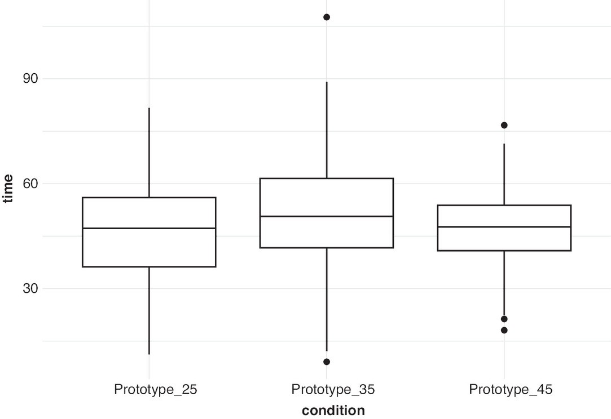

Figure 14.2 A Boxplot of Time Spent With Different Prototypes
Description

The first step is to test if our data satisfies the normality assumption by performing the Shapiro–Wilk normality test.

Across all the conditions, we see that the p value is more than 0.05 (see Table 14.2). This shows that our data do not violate the assumption of normality.

condition | variable | statistic | p
Prototype_25 | time | 0.9922398 | 0.3874756
Prototype_35 | time | 0.9895805 | 0.2286476
Prototype_45 | time | 0.9913752 | 0.3363401

The second step tests the homogeneity of variance assumption. We use Levene’s test for homogeneity of variance across groups. The null hypothesis of this test states that variances in the three groups are the same (i.e., they are not significantly different).

The obtained p value is less than 0.05, so the null hypothesis is rejected (see Table 14.3). We can conclude that our data do not meet the assumption of homogeneity of variance. As we discussed earlier, the ideal method when the assumption of homogeneity of variance is violated is Welch’s ANOVA. We implement it next.

df1 | df2 | statistic | p
2 | 552 | 14.29075 | 9e-07

The p value of Welch’s ANOVA is less than 0.05 (see Table 14.4). This shows that the means across the three conditions are not the same. In order to find out how they differ across conditions, we use the

Games-Howell test. It compares means across all possible combinations of conditions and tests if the differences between conditions are statistically significant or not.

.y. | n | statistic | DFn | DFd | p | method
time | 555 | 4.51 | 2 | 350.8273 | 0.012 | Welch ANOVA

The results show that prototype-35 players spent statistically more time with the game than both prototype-25 and prototype-45 players (see Table 14.5).

.y. | group1 | group2 | estimate | conf.low | conf.high | p.adj | p.adj.signif
time | Prototype_25 | Prototype_35 | 4.7040084 | 0.8073325 | 8.6006842 | 0.013 | *
time | Prototype_25 | Prototype_45 | 0.8873367 | -2.2508397 | 4.0255130 | 0.784 | ns
time | Prototype_35 | Prototype_45 | -3.8166717 | -7.3036038 | -0.3297396 | 0.028 | *

Insights Derived From the A/B Test
Given the finding that prototype-35 results in greater immersiveness than prototype-25 and prototype- 45, the insights we can draw are quite informative. The results indicate that for lower levels of difficulty (prototype-25), players do not find the game immersive. However, as the difficulty level increases to prototype-35, immersiveness increases. At this point, GameV might have wrongfully concluded that increasing difficulty will always increase immersiveness since players feel a greater sense of achievement when they win more difficult games. Hence, including prototype-45 was informative since it indicated that its increased level of difficulty resulted in lowered immersiveness. The results clearly indicate that as difficulty increases, immersiveness increases initially, peaks at a certain level, and then starts to decrease. In other words, the results seem to follow an inverted-U shape. Therefore, GameV can now identify what level of difficulty should be retained to obtain the maximum immersiveness.

The A/B test we ran had one factor with multiple levels and no interactions. Interaction occurs when an experimental design has two factors (or independent variables) and we want to find the combined (or interactive) influence of the two factors on the outcome variable. Of course, there can be more than two factors; in that case, we would be examining the interactive influence of three or four factors on the outcome. However, the more factors we include in an experimental design, the larger and more complicated the design becomes, requiring that each factor’s interactive influence be examined on the outcome variable. For instance, if we had an experimental design with three factors and each of them had two levels, then the model equation would include three main effects, three two-factor interactions, and one three-factor interaction, indicating that the experimental design should include 2 * 2 * 2 = 8 groups. Assuming a sample size of 50 participants per group, we would need a sample of 400 participants.

IMPLEMENTATION USING R: THE A/B TEST
First, we import the data and the libraries rstatix,³ dplyr,⁴ and ggplot2.⁵ We then summarize the data by creating a boxplot as shown in Figure 14.2.

library(rstatix)
library(dplyr)
data_game <-
read.csv(url("http://data.mishra.us/files/chapter_NPD/data_game.csv"))

data_game %>%
group_by(condition) %>%
summarise(
count = n(),
mean = mean(time),
min = min(time),
sd = sd (time)
)

## | # | A tibble: 3 × 5
## |  | condition | count | mean | min | sd
## |  | <chr> | <int> | <dbl> | <dbl> | <dbl>
## | 1 | Prototype_25 | 195 | 46.5 | 11.2 | 15.1
## | 2 | Prototype_35 | 175 | 51.2 | 9.06 | 16.6
## | 3 | Prototype_45 | 185 | 47.4 | 18.1 | 10.7

library(ggplot2)
p <- ggplot(data_game, aes(condition,time))
p + geom_boxplot()+theme_minimal()

The average time spent with prototype-35 is higher than that with both prototype-25 and prototype-45. Next, we determine if average time spent is statistically different across the three groups.

We perform the Shapiro–Wilk normality test to test for the normality assumption.

data_game %>%
group_by(condition) %>%
shapiro_test(time)

## | # | A tibble: 3 × 4
## |  | condition | variable statistic |  | p
## |  | <chr> | <chr> | <dbl> | <dbl>
## | 1 | Prototype_25 | time | 0.992 | 0.387
## | 2 | Prototype_35 | time | 0.990 | 0.229
## | 3 | Prototype_45 | time | 0.991 | 0.336

Across all conditions, we see that the p value is more than 0.05. This shows that our data do not violate the assumption of normality.

We next use Levene’s test for homogeneity of variance across groups. The null hypothesis of this test states that the variances across the three groups is similar.
levene_test(time ~ condition,data = data_game)

## | # | A tibble: 1 × 4
## |  | df1 | df2 statistic |  | p
## |  | <int> | <int> | <dbl> | <dbl>
## | 1 | 2 | 552 | 14.3 | 0.000000889

The obtained p value is less than 0.05; hence, we conclude that our data do not meet the assumption of homogeneity of variance. We implement Welch’s ANOVA next.
welch_anova_test(time ~ condition, data=data_game)

## | # | A  tibble: | 1 | × 7
## |  | .y. | n | statistic | DFn | DFd | p  method
## | * | <chr> | <int> | <dbl> | <dbl> | <dbl> | <dbl> <chr>
## | 1 | time | 555 | 4.51 | 2 | 351. | 0.012 | Welch ANOVA

The p value of Welch’s ANOVA is less than 0.05. This shows that the means across the three conditions are not the same. In order to find out how they differ across conditions, we use the Games-Howell test.
games_howell_test(time ~ condition,data=data_game)

## | # | A | tibble: 3 × 8
## |  | .y. | group1 | group2 | estimate | conf.low | conf.high | p.adj | p.adj.sign
## | * | <chr> | <chr> | <chr> | <dbl> | <dbl> | <dbl> | <dbl> | <chr>
## | 1 | time Prototype_25 |  | Prototype_35 | 4.70 | 0.807 | 8.60 | 0.013 | *
## | 2 | time Prototype_25 |  | Prototype_45 | 0.887 | -2.25 | 4.03 | 0.784 | ns
## | 3 | time Prototype_35 |  | Prototype_45 | -3.82 | -7.30 | -0.330 | 0.028 | *

The results show that with prototype-35 players spent statistically more time than with either prototype- 25 or prototype-45.

UNDERSTANDING THE CHAPTER
- What is the difference between causal testing and correlational testing? Is A/B testing causal or correlational?
- What is the difference between a null hypothesis and an alternate hypothesis in an A/B test?
- What is the primary purpose of an A/B test?
  - To compare two different advertisement designs
  - To determine the effectiveness of an intervention between groups
  - To test the effectiveness of a new medication
  - To find correlations between variables
- Which statistical test would you use to compare the means of three or more groups?

  - t test
  - F test
  - chi-square test
  - Pearson correlation
- What is the null hypothesis in an A/B test?
  - There is a significant difference between the groups.
  - There is no significant difference between the groups.
  - The intervention causes the observed difference.
  - The observed difference is due to chance.
- What is the main advantage of using Welch’s ANOVA over the standard F test (ANOVA)?
  - It is more powerful when the variances are equal.
  - It is less sensitive to unequal variances.
  - It has a higher Type I error rate.
  - It requires fewer assumptions.
- When should you use a post hoc test after an F test (ANOVA)?
  - When the null hypothesis is rejected
  - When the null hypothesis is not rejected
  - Always after an F test
  - Only when the sample sizes are unequal
- In which situation would you choose to use Welch’s ANOVA over the standard F test?
  - When the data are normally distributed
  - When the variances within each group are equal
  - When the variances within each group are unequal
  - When the groups are dependent

ENDNOTES

- Saks-Frankel, Robin, and Kelly-Ann Franklin, “Chase Sapphire Reserve Card Review 2023,” Forbes Advisor, August 31, 2023, https://www.forbes.com/advisor/credit-cards/reviews/chase-sapphire-reserve/.

- Delacre, Marie, Daniël Lakens, and Christophe Leys, “Why Psychologists Should by Default Use Welch’s t-Test Instead of Student’s t-Test,” International Review of Social Psychology 30, no. 1 (2017).

- Kassambara, Alboukadel, “rstatix: Pipe-Friendly Framework for Basic Statistical Tests,” R package version 0.7.2 (February 1, 2023), https://CRAN.R-project.org/package=rstatix.

- Wickham, Hadley, Romain François, Lionel Henry, and Kirill Müller, “dplyr: A Grammar of Data Manipulation,” R package version 1.1.3 (September 3, 2023), https://CRAN.R- project.org/package=dplyr.

- Wickham, Hadley, ggplot2:Elegant Graphics for Data Analysis (New York: Springer-Verlag, 2016).

Descriptions of Images and Figures
Back to Figure

The figure consists of numerals 1 to 8 enclosed in a circle. On the left are the odd variables 1, 3, 5, 7 and on the right are even variables. The numerals are connected by downward arrows. From numeral 6 to 5 is an upward arrow. The numerals 1 to 8 have the descriptions Idea Generation, Idea Screening, Concept Development and testing, Business Analysis, Product Development and Design, Test Marketing, Commercialization and Evaluation and Control, respectively.

Back to Figure

The figure is a graph with 30, 60 and 90 on y-axis labeled time. On the x-axis are three criteria Prototype_25, Prototype_35 and Prototype_45 labeled condition. Within the graph is a rectangular block with a horizontal line dividing the block into two regions and a vertical line on top and bottom of the block on the left. In the middle is a block with vertical lines and two circular nodes on the top and bottom. On the right is a block with a circular node on top and two circular nodes at the bottom.

OceanofPDF.com

